Layered architecture
Webhook Ingestion & Retry Mechanism Hub
Name: KRISHNA KEERTHAN REDDY DR SRN:PES1UG24CS237 SEC:D
For the Webhook Ingestion & Retry Mechanism Hub layered architecture was selected because the system contains different types of responsibilities that can be separated into different layers. This makes the system easier to understand, develop and test.
The architecture is divided into three layers: presentation layer, business layer and data layer where each layer has its own responsibility.
The Presentation Layer is responsible for interaction with the users and external systems. It contains the Webhook Gateway Interface, Operator Interface and Delivery Status Interface. The webhook interface receives events from third-party providers, while the operator and status interfaces allow the system operator to check the system and delivery information. These components do not directly handle database operations.
The Business Layer contains the main functionality of the webhook system. Components such as the Webhook Ingestion Service, Delivery Service, Retry Scheduler and Dead-Letter Queue Manager are placed here. This layer handles accepting webhook events, forwarding them to internal services, retrying failed deliveries using exponential backoff and moving events to the dead-letter queue when the retry attempts are exhausted.
The Data Layer manages the storage and retrieval of information. It contains the Event Repository, Delivery Log and Dead-Letter Queue. The business layer communicates with these components instead of directly managing storage. Therefore, changes to the storage mechanism can be handled within the data layer without major changes to the interfaces or business services.
One advantage of layered architecture is separation of concerns. Each layer has a specific responsibility, which reduces unnecessary dependencies between components. The system can also be tested layer by layer. For example, the delivery service can be tested independently from the interface and the storage implementation.
One test case: when a third-party provider sends a webhook, the request starts from the Webhook Gateway Interface, is handled by the Webhook Ingestion Service, and the event information is stored through the Event Repository. The Delivery Service then sends the payload to the internal target service. If delivery fails, the Retry Scheduler handles the retry process and the DLQ Manager stores the event if the retry limit is reached.
Security advantage: the presentation layer acts as the controlled entry point for external webhook requests. Validation can be performed before the request is passed to the business layer, while the data layer is kept separate from direct external access.
Performance benefit: separating ingestion from delivery and retry processing prevents retry operations from directly blocking the incoming request path. Events can be stored and processed by the appropriate business component, which helps the system handle a high number of webhook requests.
Conclusion: Layered Architecture was selected because it provides clear separation of responsibilities, reduces coupling between different parts of the system, simplifies maintenance and testing, and provides a structured way to implement webhook ingestion, delivery, retry and dead-letter handling.

Webhook Ingestion & Retry Mechanism Hub - layered architecture

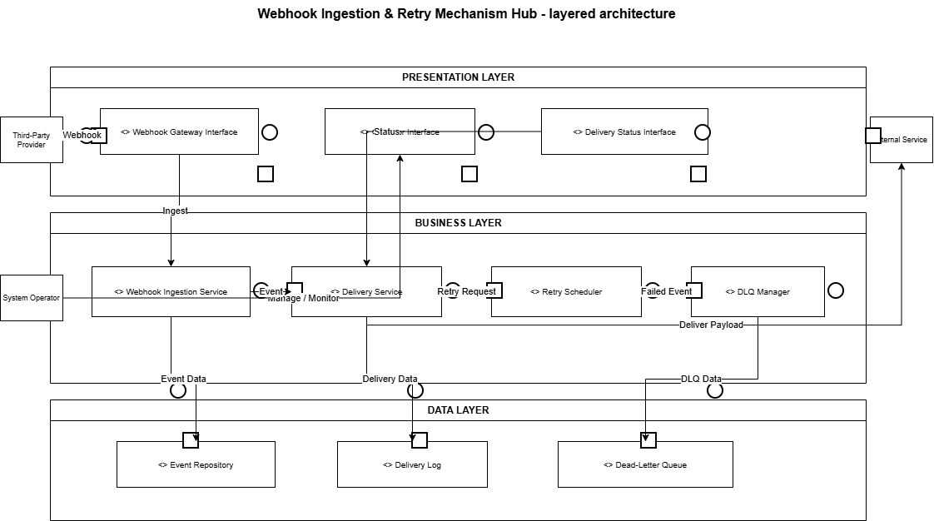

The circles and semicircles on the component boundaries represent the provided and required interfaces, matching the notation used in the samp

